Risk and Resilience Framework for Children, Youth, and Family Policy
Student’s Name
Institution Affiliation

Risk and Resilience Framework for Children, Youth, and Family Policy
Risk factors for youths and children may be personal, peer, school, family, and influenced by the community that expands the probability of a child to encounter health concerns. Identification of risk factors to challenges that children and adolescents face has been accepted widely in the field of prevention, but its origin is relatively new (Jenson, & Fraser, 2006). Risk factors are conditions, events or experiences that increase the probability of a problem to be developed, maintained, or aggravated. The discussion shall dwell on evidence-based intervention that could be introduced in the organization to help children and adolescents that have been predisposed to the factors.
Risk Factors Identified for the Intervention
The risk factors include environmental, individual, and interpersonal factors. Notably, the evidence-based intervention shall respond to neighborhood disorganization, family conflict and communication, and family history of substance use — a new approach in modeling the root causes of the factors that consistently led to cases of delinquency, suicide, dropping out from school, among other challenges (Jenson, & Fraser, 2006).
Evidence-Based Intervention Program
The intervention program selected that will yield positive results for children exposed to the risk factors is the ecological theory and life course development. The program assesses the development of the child by analyzing interaction between psychological and biological aspects of the particular child and their environment (Gewirtz, & Edleson, 2007).
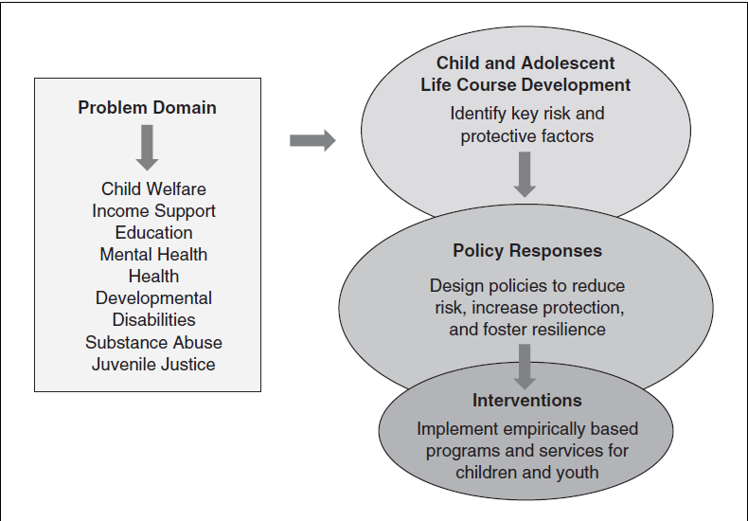
The intervention program shall be framed in the ecological context that takes into account the influence of context (Fraser, Kirby, & Smokowski, 2004).
Specific examples
For instance, children in the juvenile system of justice are also confined to a unit that has a family setting, goes to school, and develops networks of peers. Evidence indicates that both inter-related and unique risks, as well as protective elements, escalate or reduce the probability of problem behavior in each of the contexts. Consequently, social policies tend to be more effective when they can respond to the various influences that cultivate or aggravate the behavior in young people (Jenson, & Fraser, 2006).

References
Fraser, M. W., Kirby, L. D., & Smokowski, P. R. (2004). Risk and resilience in childhood. Risk and resilience in childhood: An ecological perspective, 2, 13-66.
Gewirtz, A. H., & Edleson, J. L. (2007). Young children’s exposure to intimate partner violence: Towards a developmental risk and resilience framework for research and intervention. Journal of Family Violence, 22(3), 151-163.
Jenson, J. M., & Fraser, M. W. (2006). A risk and resilience framework for child, youth, and family policy. Social policy for children & families: A risk and resilience perspective, 118.

